

Q-Learning Management System
User manual

How to login
Go ahead to https://lms.quickstopsolution.com

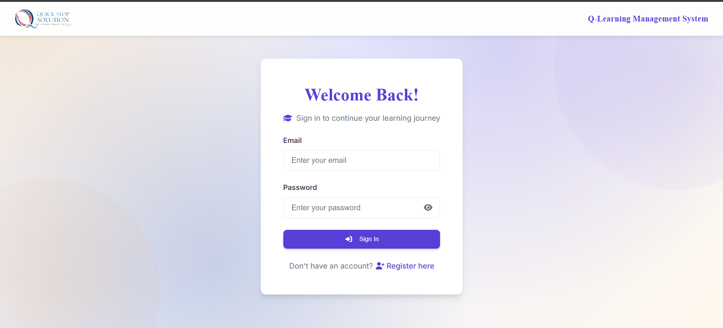
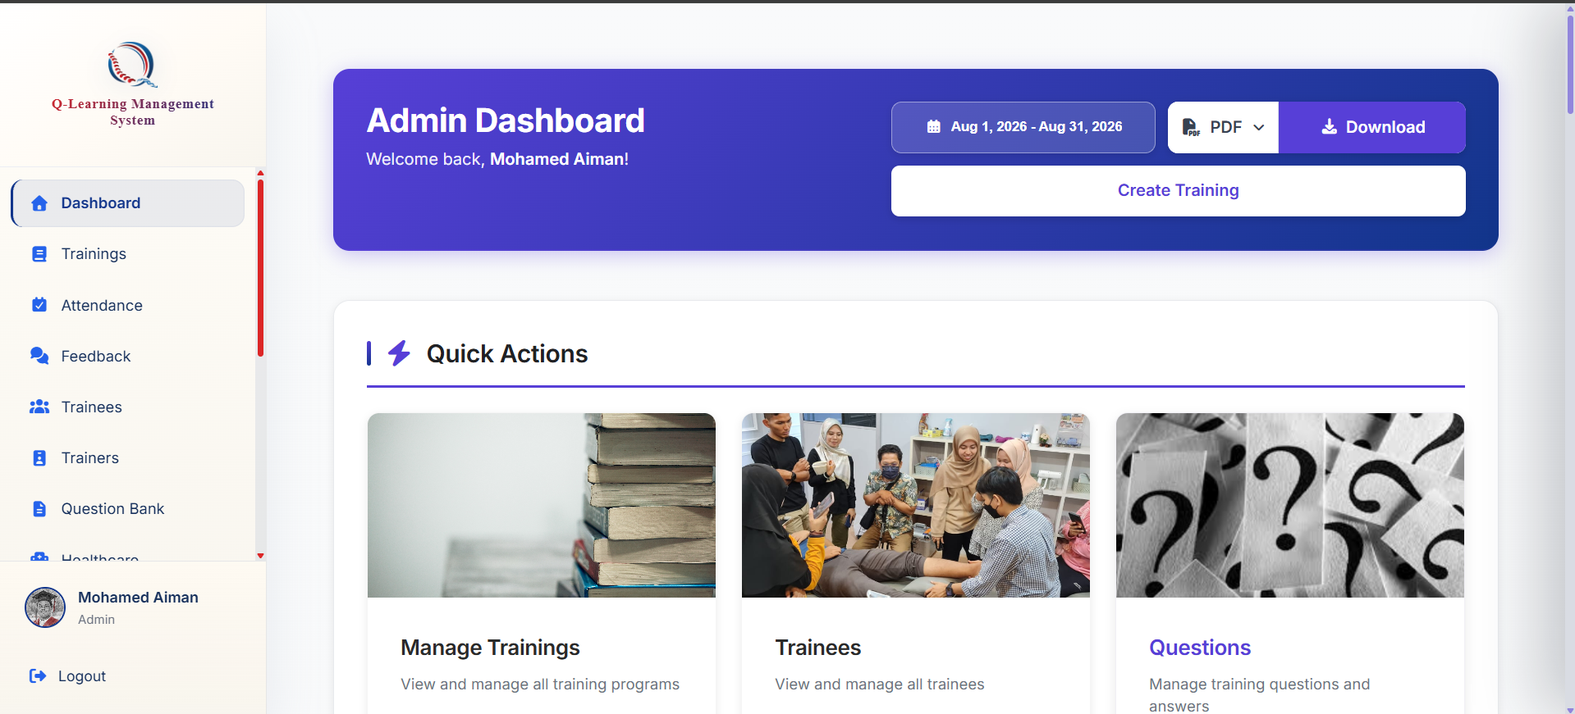
After signing in, you would be brought to your relevant dashboard
Then press sign in here
Enter your email and password accordingly here

